Guidelines for the Progress Report
and the Design Document

Team Name:

Country:

Progress Report

In general, a progress report should convey the following information:
- The work that has been completed
- The work that is in progress
- The work that remains to be done
- Any problems, complications or other issues you have encountered
- A general overview of how the project is going

The progress reports will consist of 4 parts:
- Progress statement for your online profile (1-2 paragraphs)
- Task list
- Detailed project status
- Your updated Design Document

The progress statement should consist of 1-2 paragraphs (max), and is intended for your online profile page. This is a general statement to give the public an idea of how things are going with your project. (More detailed information intended for ESA and NAROM should be put into the “Project Status” section)

In the “Task List” section, you should break down the project work into a list of individual tasks, and indicate which ones have been completed, which ones are in progress, and which ones remain to be done.

In the “Detailed Project Status” section, write any comments you have about any specific issues you are having, and let us know how the project is going in general. Although there is no minimum length for this section, we encourage you to go more in-depth here than with the progress statement for your online profile page. The information you provide in this section will not be posted on your team profile page.

As your project progresses, you should be constantly updating your design document to reflect the work you have done. We will therefore use both the Progress Report and the current version of your Design Document to help us gauge your overall progress. When completing an interim design document, fill in as much information as possible based on the current status of the project.

Note: the Progress Report is not meant to replace the “Project Planning” chapter of the Design Document.

- New progress statement for team profile
A brief statement (1-2 paragraphs max) to give the general public an idea of how things are going with your project.

- Task list
When creating your task list, try to break complex tasks down into simple ones as much as possible. Shown below is an example of one possible way you could organise your task list. You are free, however, to format your information in another way if you wish.

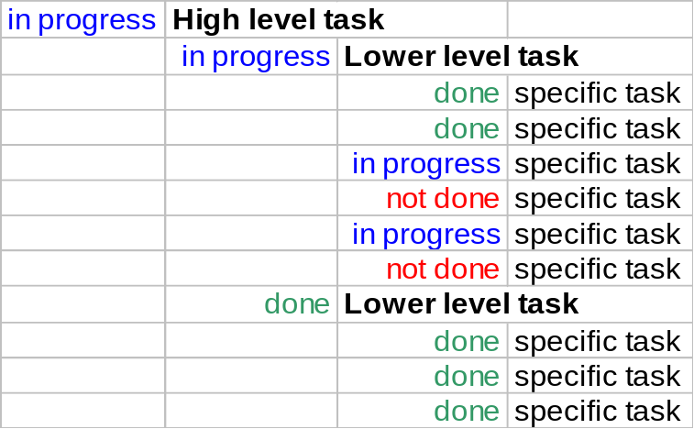

- Detailed project status
Write any comments you have about any specific issues you are having. Also let us know how the project is going in general. Feel free to go into detail, this information will not be posted on your team profile page.

Design Document

The process of building a satellite is very complex and costly. That is why, in a real satellite mission, there are some documents that have to be delivered before, during and after the satellite is built. These documents serve to provide detailed information about the satellite being developed and to ensure that it complies with all the requirements regarding the mission and the launch environment.

The process of designing and building a CanSat is much simpler than the one followed for a satellite. Nevertheless, we believe that exposing students to good engineering procedures will be very beneficial for their educational experience.

These guidelines provide information about the expected content of each chapter. This information will ensure that the work you are doing is aligned with your mission goals and it can help us to identify possible problems at an early stage. It will also help us to determine that your CanSat will be able to fly according to the mechanical and safety requirements.

Attached to this document there is a blank design document with a given structure that you can modify to describe all the aspects of your CanSat project. There is no limit to the number of pages used but it should be well-structured and appendices should be used for detailed information to keep the main body of the document as concise as possible. This detailed information may be e.g. details of scientific background, technical drawings or component datasheets. The documentation should be written in a clear and concise manner that allows a person who does not know the experiment to understand its purpose and design.

The design document should provide ESA and NAROM with all important information on the experiment. During all experiment phases the design document is the only documentation for describing the experiment in detail. The chapters can be modified and additional sections can be added by the experiment team if appropriate. The design document will be one of the evaluating criteria for the jury of the European CanSat competition.

Table of Contents
Progress Report 2
i. New progress statement for team profile 3
ii. Task list 4
iii. Detailed project status 5
Design Document 6
1 INTRODUCTION 8
1.1 Team organisation and roles 8
1.2 Mission objectives 8
2 Cansat Description 9
2.1 Mission overview 9
2.2 Mechanical/ structural design 10
2.3 Electrical design 11
2.4 Software design 11
2.5 Recovery system 12
2.6 Ground support Equipment 12
3 Project Planning 13
3.1 Time schedule of the CanSat preparation 13
3.2 Resource estimation 13
3.2.1 Budget 13
3.2.2 External support 13
3.3 Test plan 13
4 outreach programme 14
5 Requirements 16
APPENDIX 1 The CanSat Requirements 17

INTRODUCTION

Team organisation and roles

Present the teacher, the team members and their respective roles in the team.

Include their:

- Background, path that they are following if applicable (pure sciences, maths, etc) and interests (e.g. physics, computer science, mechanical engineering, etc.).
- Field of work within the team, giving details of tasks
- Expected workload within the team (in general terms)
- Hours dedicated at school, (e.g. 1h per week during physics course)
- Hours dedicated after school

Mission objectives

Describe your secondary mission and the reasons why you selected that mission.

Define which objectives should be reached in order for the CanSat launch to be considered successful.

What result do you expect from your research?

What are you going to measure/investigate/test?

Cansat Description

Mission overview

Give an overview of how the missions will be carried out.

E.g: Design and build a CanSat to be launched and deployed from a rocket at an altitude of about 450 meters. The CanSat is to descend no faster than 4.6 meters per second. Once landed, the CanSat will measure the soil surface temperature and record the data every 5 minutes for two hours minimum.

Please take into account that this definition is just an example and has nothing to do with the real missions that you will perform.

Name the key elements that you will use to accomplish them (e.g. sensors, cameras, materials to be tested).

We are providing you with a block diagram that is not completed; you should fill it in with all the functional and/or physical blocks of the experiment and describe in general terms how these elements interact, without providing any technical detail.

The mission overview should not describe any design choices!

Block diagram:

Microcontroller

Transmitter

Ground Station

Mechanical/ structural design

Describe the mechanical design, the material used for the CanSat structure and how every component is mounted to the structure. Identify the major components of the CanSat and include a preliminary drawing or picture of how the CanSat structure will look and where the major components such as main board, sensors, transmitter, and battery will be placed.

Include mechanical drawings and a list of parts. Explain what each part of the CanSat does.

Electrical design

Describe the electrical interface (and selected components) of the CanSat – you can use electronic drawings.

If applicable, describe the usage of the RF link (data rate of downlink, protocol, data rate of uplink).

Provide a power budget, detailing how much power each component consumes and battery capacity. Make an estimation of the power consumption and the duration of the batteries.

If batteries are used, give their type and number.

Software design

Describe the software design of the CanSat and how is expected to work and detail the On-Board Data Handling (OBDH).

Give a flow diagram of the software program flow. If applicable, describe different software modes.

Estimate the amount of data gathered and discuss its storage on-board the experiment or its transfer to the ground segment.

Indicate what programming language(s) and development environments are used.

Recovery system

Give a brief description of the recovery system used and the method used to fix it to the CanSat structure. You can add a picture of a design.

Indicate the expected flight time.

Ground support Equipment

Describe all equipment that is part of the experiment but that does not fly on the rocket. Usually, this is the ground segment, one or several computers that receive data from the experiment, a radio receiver, etc. Describe the software design of the ground segment and detail the handling of received data.

Indicate the transmitter frequency that you are going to use for data transmission/reception between your CanSat and the ground station.

Project Planning

Time schedule of the CanSat preparation

Provide a schedule that includes the phases of design, prototyping, construction, testing, and all key dates.

Resource estimation

Budget

List all the foreseen costs in a table form. Make sure that the total budget of your CanSat does not exceed 500€. Include €200 as the cost of the Pratt Hobbies CanSat kit, if you received one of these from ESA at the Teachers’ Introductory Workshop.

External support

List the organisations, departments or companies that provide sponsorship or in-kind support. For example, professors of a university or institute, local companies or nearby research laboratories, facilities to which access is possible, etc. Mention any support or expertise which is lacking.

Test plan

Describe all the tests that will be performed in order to verify that your CanSat can carry out both the primary and secondary missions.
Describe also any test developed to verify the correct deployment of the recovery system of the CanSat (parachute, airbag, etc).
You can add videos, graphics or pictures.

outreach programme

Outline the approach to publicising and communicating about your project.

Describe the team’s website or blog and how it is planned to evolve.

Include a summary list or table of all outreach actions performed and media coverage received. This should include:

- The URL of the website / blog
- Any performed outreach actions, e.g. publishing press releases, contacting journalists, designing a logo or information brochure
- Details of media coverage, e.g. newspaper articles, radio / TV interviews, internet news articles, etc
- Presentations given by the team members, e.g. at the school or a local event
- Exhibitions of the experiment, e.g. at a fair or school open day
Attach copies or photographs of the above if possible and include reference numbers in the list.

Requirements

In order to be able to launch the CanSat safely from the Rocket, the CanSat should meet the requirements listed in the competition guidelines available in APPENDIX 1.

Complete the following table by specifying the exact characteristics of your CanSat. Please make sure that the figures indicated here correspond to the same figures in other sections of the document.

Characteristics | Figure
Height of the CanSat
Mass of the CanSat
Diameter of the CanSat
Length of the recovery system
Flight time scheduled
Calculated descent rate
Radio frequency used
Power consumption
Total cost

On behalf of the team I confirm that our CanSat complies with all the requirements established for the European CanSat competition in the official Guidelines, APPENDIX 1 of this document.

Signature, place and date

APPENDIX 1 The CanSat Requirements
- All the components of the CanSat must fit inside a standard soda can (115 mm height and 66 mm diameter), with the exception of the parachute, radio antennas and GPS antennas, which can be mounted externally (on the top or bottom of the can, not on the sides). NOTE: the rocket payload area has 4.5cm of space available per CanSat, along the can’s axial dimension (i.e. height), which must accommodate all external elements including: parachute, parachute attachment hardware, and any antennas.
- The antennas, transducers and other elements of the CanSat cannot extend beyond the can’s diameter until it has left the launch vehicle.
- The maximum mass of the CanSat is limited to 350 g.
- Explosives, detonators, pyrotechnics, and flammable or dangerous materials are strictly forbidden. All materials used must be safe for the personnel, the equipment and the environment. Material Safety Data Sheets (MSDS) will be requested in case of doubt.
- The CanSat must be powered by a battery and/or solar panels. It must be possible for the systems to be switched on for three continuous hours.
- The battery must be easily accessible, in case it has to be replaced or recharged in the field.
- The CanSat should have a recovery system, such as a parachute, which is able to be reused after launch. It is recommended to use bright coloured fabric, which will facilitate recovery of the CanSat after landing.
- The parachute connection must be able to withstand up to 1000N of force. The strength of the parachute must be tested, to give confidence that the system will operate nominally.
- The flight time is limited to 120 sec.
- The descent rate must be between 8 m/s and 11m/s.
- The CanSat must be able to withstand an acceleration of up to 20g.
- The total budget of the CanSat should not exceed €500.
If your team has any problems fulfilling some of these terms, please contact the competition organisers for advice. Failure to meet the requirements will be taken into consideration by the jury but will not necessarily prevent the CanSat from being launched.

